**Assignment 6: User Management**

1. Write a script that adds a new user to the system with a specified username, home directory and password

#!/bin/bash

USERNAME="$1"

HOMEDIR="$2"

PASSWORD="$3"

useradd -m -d "$HOMEDIR" "$USERNAME"

echo "$USERNAME:$PASSWORD" | chpasswd

echo "User $USERNAME created with home directory $HOMEDIR"

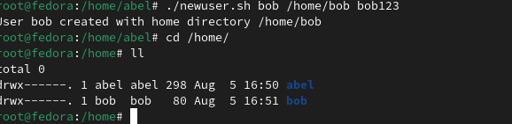

2.Develop a script that checks the strength of a user's password

#!/bin/bash

PASSWORD="$1"

echo "$PASSWORD" | perl -ne '

if (/^(?=.*[a-z])(?=.*[A-Z])(?=.*\d)(?=.*[\W_]).{8,}$/) {

print "Strong password\n";

} else {

print "Weak password\n";

}

'

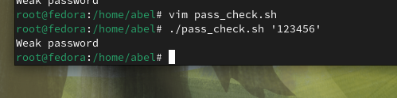

3.Create a script that lists all users in the system and their login times.

cut -d: -f1,3 /etc/passwd | awk -F: '$2 >= 1000 {print $1}' | xargs -n1 lastlog -u

